Mathematical Problem

🌟 Definition
# Source: AI Source: Provided by: [Data Path: Persons Table -> ID Column: 1, Name_En Column: Motasem Essam] -> From: [ChatGPT] on [5/29/2026]
A mathematical problem is a question or situation that requires mathematical methods, reasoning, or calculations to find a solution.
It usually involves given information and a goal to be found or proven.

🎯 Purpose of a Mathematical Problem
# Source: AI Source: Provided by: [Data Path: Persons Table -> ID Column: 1, Name_En Column: Motasem Essam] -> From: [ChatGPT] on [5/29/2026]
- To apply mathematical concepts in practice
- To develop problem-solving skills
- To test understanding of mathematical ideas
- To model real-life situations
- To discover unknown values or relationships

📚 Key Characteristics
# Source: AI Source: Provided by: [Data Path: Persons Table -> ID Column: 1, Name_En Column: Motasem Essam] -> From: [ChatGPT] on [5/29/2026]
A mathematical problem:
- Has a clear question or task
- Includes known and unknown information
- Requires logical thinking and calculation
- May use equations, formulas, or proofs
- Has one or more correct solutions (or sometimes no solution)

🧩 Structure of a Mathematical Problem
# Source: AI Source: Provided by: [Data Path: Persons Table -> ID Column: 1, Name_En Column: Motasem Essam] -> From: [ChatGPT] on [5/29/2026]
- Given data (known information)
- Unknowns (what we need to find)
- Conditions or rules
- Solution process
- Final answer

✏️ Types of Mathematical Problems

1. Arithmetic Problems
# Source: AI Source: Provided by: [Data Path: Persons Table -> ID Column: 1, Name_En Column: Motasem Essam] -> From: [ChatGPT] on [5/29/2026]
Simple calculations with numbers.
Example:
- What is 15 + 27?

2. Algebraic Problems
# Source: AI Source: Provided by: [Data Path: Persons Table -> ID Column: 1, Name_En Column: Motasem Essam] -> From: [ChatGPT] on [5/29/2026]
Involve variables and equations.
$$2x+3=11$$

3. Word Problems
# Source: AI Source: Provided by: [Data Path: Persons Table -> ID Column: 1, Name_En Column: Motasem Essam] -> From: [ChatGPT] on [5/29/2026]
Real-life situations written in words.
Example:
- A train travels 60 km in 1 hour. How far will it travel in 5 hours?

4. Geometry Problems
# Source: AI Source: Provided by: [Data Path: Persons Table -> ID Column: 1, Name_En Column: Motasem Essam] -> From: [ChatGPT] on [5/29/2026]
Deal with shapes, angles, and space.
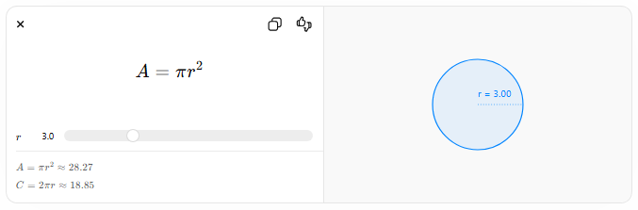
$$A=πr^{2}$$
$$r$$
$$A=πr^{2}≈28.27$$
$$C=2πr≈18.85$$
r = 3.00

5. Logical Problems
# Source: AI Source: Provided by: [Data Path: Persons Table -> ID Column: 1, Name_En Column: Motasem Essam] -> From: [ChatGPT] on [5/29/2026]
Require reasoning instead of calculation.
Example:
- If all squares are rectangles, and this shape is a square, what is it?

6. Proof Problems
# Source: AI Source: Provided by: [Data Path: Persons Table -> ID Column: 1, Name_En Column: Motasem Essam] -> From: [ChatGPT] on [5/29/2026]
Require proving a statement is true.
Example:
- Prove that the sum of two even numbers is even.

🔗 Relationship to Other Concepts
# Source: AI Source: Provided by: [Data Path: Persons Table -> ID Column: 1, Name_En Column: Motasem Essam] -> From: [ChatGPT] on [5/29/2026]
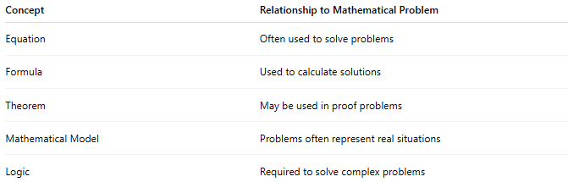
Concept | Relationship to Mathematical Problem
Equation | Often used to solve problems
Formula | Used to calculate solutions
Theorem | May be used in proof problems
Mathematical Model | Problems often represent real situations
Logic | Required to solve complex problems

📖 Problem vs Equation vs Problem-Solving
# Source: AI Source: Provided by: [Data Path: Persons Table -> ID Column: 1, Name_En Column: Motasem Essam] -> From: [ChatGPT] on [5/29/2026]
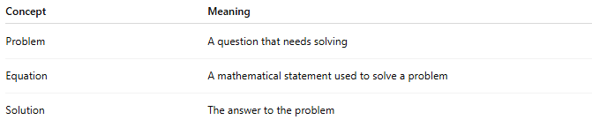
Concept | Meaning
Problem | A question that needs solving
Equation | A mathematical statement used to solve a problem
Solution | The answer to the problem

🧠 Simple Analogy
# Source: AI Source: Provided by: [Data Path: Persons Table -> ID Column: 1, Name_En Column: Motasem Essam] -> From: [ChatGPT] on [5/29/2026]
A mathematical problem is like a puzzle:
- Pieces = given information
- Goal = completed picture
- Method = mathematical reasoning

🧭 Summary
# Source: AI Source: Provided by: [Data Path: Persons Table -> ID Column: 1, Name_En Column: Motasem Essam] -> From: [ChatGPT] on [5/29/2026]
A mathematical problem is a question that requires mathematical thinking, formulas, equations, or logic to solve. It is used to apply mathematics to find unknown values, prove statements, or understand real-world situations.

